**Helpdesk Ticketing System**

**UIT2211 – SOFTWARE DEVELOPMENT PROJECT –I**

**A PROJECT REPORT**

***Submitted by***

|  |  |
| --- | --- |
| **Devanithimaran E** | **3122 23 5002 029** |
| **Dharanikaran S** | **3122 23 5002 030** |
| **Dhaya Ananth M M** | **3122 23 5002 031** |
| **Dhivakaran S** | **3122 23 5002 032** |

**SSN COLLEGE OF ENGINEERING, KALAVAKKAM**

**JUNE 2024**



**Sri Sivasubramaniya Nadar College of Engineering**

**(An Autonomous Institution, Affiliated to Anna University)**

**BONAFIDE CERTIFICATE**

Certified that this project titled “Helpdesk Ticketing System” is the bonafide work of “Devanithimaran E-3122235002029, Dharanikaran S - 3122235002030, Dhaya Ananth M M - 3122235002031, Dhivakaran S – 3122235002032 and is submitted for project viva-voce examination held on 18.06.2024.

**Signature of examiner(s)**

# INDEX

|  |  |  |
| --- | --- | --- |
| **S.No** | **Content** | **Page Number** |
| 1 | Problem Statement | 1 |
| 2 | Abstract | 2 |
| 3 | Client Details | 3 |
| 4 | Introduction | 4 |
| 5 | Requirement Engineering | 5 |
| 6 | Implementation and Risk Management | 8 |
| 7 | Meeting Reports | 13 |
| 8 | Results | 14 |
| 9 | Screenshots of user-interface | 17 |
| 10 | Client Evaluation Report | 22 |
| 11 | Conclusion | 23 |
| 12 | References | 24 |

**PROBLEM STATEMENT**

An organization like SSN College of Engineering wants to develop a Helpdesk ticketing system. Any member of the organization should be able to log a request/complaint regarding certain services. The system should assign a unique ticket number for each request. A ticket should be assigned to a service engineer based on the service type. A service engineer should be able to view all the tickets assigned to them. Once the service is completed, the service engineer will close the ticket. The management should be able to generate various reports for analyzing and improving the services.

# ABSTRACT

The Helpdesk Ticketing System is a comprehensive software solution developed to address the specific needs of SSN College of Engineering. This system is designed to streamline the process of managing service requests and complaints, ensuring efficient resolution and improving overall service quality within the institution. The existing manual system for handling service requests results in inefficiencies, delays, and lack of accountability. To overcome these challenges, the college requires an automated system that ensures seamless request management and enhances operational efficiency.

The motivation behind developing the Helpdesk Ticketing System is to optimize workflow, improve service delivery, and enhance the experience for all members of SSN College of Engineering. By implementing a comprehensive software solution, the college aims to minimize administrative burdens, reduce response times, and ensure accountability. This will result in increased user satisfaction and improved service management. The objective is to deliver a user-friendly and efficient platform that enables members to log service requests or complaints, track their progress, and ensure timely resolution. The system will streamline the entire process from request logging to resolution, facilitate effective communication, and provide valuable insights through report generation.

The Helpdesk Ticketing System includes features such as automated ticket generation, assignment to service engineers based on service type, and progress tracking. Members of the organization can easily log requests or complaints, which are then assigned unique ticket numbers for tracking. Service engineers benefit from a clear view of all assigned tickets, enabling efficient management and resolution. Once a service is completed, the engineer closes the ticket, ensuring transparency and accountability. The management can generate various reports for analyzing service performance and identifying areas for improvement. This centralized platform fosters seamless communication among members, service engineers, and management, enhancing overall service quality and operational efficiency. The system is securely hosted and ensures data protection, offering reliable access through a web-based interface.

.

# CLIENT DETAILS

Dr.Jaish P,

Department of Mathematics,

SSNCE,

Chennai – 603110.

Email ID: jaishp@ssn.edu.in

Phone Number: 9585366456

# INTRODUCTION

In the dynamic environment of educational institutions, efficient management of service requests and prompt resolution of issues are crucial for maintaining smooth operations and ensuring satisfaction among students, faculty, and staff. The Helpdesk Ticketing System project, developed by a dedicated team of engineers, addresses these needs by offering a comprehensive software solution for SSN College of Engineering. The system aims to revolutionize the way service requests and complaints are managed, promoting seamless communication between service engineers, administrators, and users.

At the core of the Helpdesk Ticketing System is an intuitive admin page, where administrators can easily view and manage service requests and assignments. Each service engineer is granted personalized login credentials, enabling them to access the application and perform a variety of tasks. Service engineers can view all assigned tickets, update their status, and ensure timely resolution of issues. The system's ticket assignment functionality ensures that each service request is directed to the appropriate engineer based on the service type, facilitating efficient issue resolution.

Users, upon logging in, gain access to a straightforward interface where they can log service requests or complaints. Each request is assigned a unique ticket number, enabling users to track the progress of their requests. Users can also view the history of their previous requests and any communications related to their tickets. Email notifications are sent to confirm the creation of new tickets and to update users on the status of their requests, ensuring a seamless and transparent process.

Administrators play a pivotal role in the Helpdesk Ticketing System. They can generate various reports for analyzing service performance, identify areas for improvement, and ensure accountability. Additionally, administrators have the capability to manage user accounts, view detailed logs of all activities within the system, and ensure the overall security and efficiency of the ticketing process.

To enhance security and user convenience, the system incorporates a robust authentication mechanism. Moreover, the project has been successfully hosted on PythonAnywhere, offering secure and reliable access to the system.

The Helpdesk Ticketing System project aims to optimize the management of service requests, improve response times, and enhance the overall experience for all members of SSN College of Engineering. By leveraging technology and implementing a user-friendly software solution, the institution can streamline its processes, maintain accurate records, and deliver exceptional service to its community

**REQUIREMENT ENGINEERING**

|  |  |  |  |  |  |  |
| --- | --- | --- | --- | --- | --- | --- |
| **SPRINT** | **EPIC** | **USER STORY #** | **REQUIREMENT/**  **USERSTORY** | **ESSENTIAL**  **/DESIRABLE** | **DESCRIPTION OF REQUIREMENTS** | **REMARKS** |
| 1 | User Authentication | 1 | |  | | --- | | Create login |  |  | | --- | |  | | Essential | By entering the correct credentials, the user must be able to access their data. | The login will be successful after entering the correct password. |
| 1 | User Authentication | 2 | New Registration | Essential | To create new user (client) login credentials. | New credentials will be generated after registration. |
| 1 | User Home Page | 4 | View Homepage | Essential | Every user will have their own customized home pages. | Each user cannot access any other users’ homepage. |
| 1 | Complaint Management | 5 | Log Complaint | Essential | Users can log complaints regarding various issues. | A ticket number is generated and sent via email. |
| 1 | Complaint Management | 6 | Check Complaint Status | Essential | Users can check the status of their complaints using a ticket number. | Status is fetched from the database and displayed. |
| 1 | Complaint Management | 7 | Update Complaint Status | Essential | Technicians can update the status of complaints. | Status is updated in the database. |
| 1 | Agent Dashboard | 8 | View Assigned Tickets | Essential | Technicians can view tickets assigned to them based on their help topic. | Tickets are displayed sorted by preferred time. |
| 1 | Admin Dashboard | 9 | Admin Login | Essential | Admin can log in to access administrative functionalities. | Admin has access to view all feedback and resolved tickets. |
| 1 | |  | | --- | | Feedback  Manage  ment |  |  | | --- | |  | | 10 | Submit Feedback | Essential | Users can submit feedback for resolved tickets. | Feedback is saved in the database. |
| 1 | |  | | --- | | Feedback  Manage  ment |  |  | | --- | |  | | 11 | View Feedback | Desirable | Admin can view feedback submitted by users. | Feedback is displayed in the admin dashboard. |
| **SPRINT** | **EPIC** | **USER STORY #** | **REQUIREMENT/**  **USERSTORY** | **ESSENTIAL**  **/DESIRABLE** | **DESCRIPTION OF REQUIREMENTS** | **REMARKS** |
| 2 | Agent Dashboard | 12 | |  | | --- | | Agent Login |  |  | | --- | |  | | Essential | Technicians can log in to view and manage their assigned tickets. | Technicians can update ticket statuses and view details. |
| 2 | |  | | --- | | Ticket  Managem  ent |  |  | | --- | |  | | 13 | |  | | --- | | Load Data to  Hash Table |  |  | | --- | |  | | Essential | Load existing complaint data into hash tables on startup. | Ensures efficient retrieval and management of tickets. |
| 2 | |  | | --- | | Ticket  Managem  ent |  |  | | --- | |  | | 14 | Save Data from Hash Table | Essential | Save the current state of hash tables to JSON files before shutdown. | Prevents data loss and ensures persistence. |
| 2 | |  | | --- | | Ticket  Managem  ent |  |  | | --- | |  | | 15 | Append to Resolved JSON | Essential | Append resolved tickets to their respective JSON files. | Helps in maintaining a record of resolved tickets. |
| 2 | Notification System | 16 | Send Email Notification | Essential | Send email notifications to users upon ticket creation and updates. | Users receive confirmation and status update emails. |
| 2 | Data Validation | 17 | Validate Ticket Information | Essential | Validate ticket information before saving to the database. | Ensures data integrity and prevents errors. |
| 3 | Admin Dashboard | 18 | View All Feedback | Desirable | Admin can view all feedback submitted by users. | Feedback is displayed in a summarized view on the admin dashboard. |
| 3 | Admin Management | 20 | Manage Users and Agents | Essential | Admin can view, add, and manage users and agents. | Admin has the ability to update roles and credentials. |
| 3 | Data Security | 21 | Session Management | Essential | Ensure secure session management for users, agents, and admin. | Prevent unauthorized access and maintain session integrity. |
| **SPRINT** | **EPIC** | **USER STORY #** | **REQUIREMENT/**  **USERSTORY** | **ESSENTIAL**  **/DESIRABLE** | **DESCRIPTION OF REQUIREMENTS** | **REMARKS** |
| 3 | Ticket Assignment | 22 | Assign Tickets to Agents | Essential | Automatically assign tickets to agents based on help topics. | Ensures that the correct agent handles the appropriate tickets. |
| 4 | |  | | --- | | Data  Analysis |  |  | | --- | |  | | 23 | |  | | --- | |  |  |  | | --- | | Generate Reports | | Desirable | Generate reports based on ticket data, including resolved and pending tickets. | Reports can be used for analysis and improving service efficiency. |
| 4 | User Interface | 24 | Improve UI for Ticket System | Desirable | Enhance the user interface for better usability and user experience. | UI improvements to make navigation and interaction more intuitive. |
| 4 | Feedback Management | 25 | Analyze Feedback | Desirable | Analyze feedback to identify common issues and areas for improvement. | Feedback analysis helps in improving the overall service quality. |
| 4 | Real-Time Updates | 26 | Real-Time Ticket Updates | Desirable | Implement real-time updates for ticket status changes. | Users and agents receive immediate updates on the status of tickets. |

# IMPLEMENTATION AND RISK MANAGEMENT

**Name and Register Number:** DEVANITHIMARAN E **–** 3122 23 5002 029

DHIVAKARAN S **–** 3122 23 5002 032

**Role in the Project:** Developer

1. **Implementation**

|  |  |  |  |
| --- | --- | --- | --- |
| **Sprint** | **Epic** | **Requirement / User Story** | **Remarks on implementation** |
| 1 | Frontend Development & Routing | User friendly pages to perform various tasks | Created various pages and configured their respective routes |
| 3 | Form handling | Submit complaint and feedback | Created and managed form handling |
|  |  |  |  |

1. **Risk Management**

|  |  |  |  |  |
| --- | --- | --- | --- | --- |
| **Risk Management** | **Risk Description** | **Probability** | **Impact** | **Mitigation Plan** |
| Integration Issues | Challenges in integrating frontend with backend for complaint logging and ticket system. | Medium | High | Conduct regular integration testing  ,referring many websites,github and youtube |
| Coordination issues | Coordination of my pair coder | Medium | High | Discussing through Whatsapp and having clear conversation through phone calls |
| Client demand management | Meeting client demands | High | Medium | Completing essential requirements first and working on desirable ones |

1. **Test Log Report**

|  |  |  |  |  |  |
| --- | --- | --- | --- | --- | --- |
| **TC**  **id** | **RS #** | **Test case description/ condition** | **Test case input** | **Expected Output** | **Result**  **(PASS/ FAIL)** |
| 1. | 1 | Verify complaint log form submission with all required fields filled. | Enter valid details for help topic, description, location, room no, mob no, preferred time, click submit. | Complaint is successfully logged, and confirmation email is sent. | PASS |
| 2 | 3 | Verify complaint log visibility after logging in. | Log in with a valid user account and navigate to complaint log. | User's complaint log is displayed with all relevant complaints listed. | PASS |
| 3 | 2 | Verify all essential details in all pages and proper functionality | Regular review of html,css and js code | All essential details are displayed with proper functionality | PASS |

**Name and Register Number:** DHARANIKARAN S – 3122 23 5002 030

**Role in the Project:** Developer

1. **Implementation**

|  |  |  |  |
| --- | --- | --- | --- |
| **Sprint** | **Epic** | **Requirement / User Story** | **Remarks on implementation** |
| 1 | Complaint Logging system | log a complaint with details such as help topic, description, location, and preferred time. | Implemented form handling, data validation, ticket ID generation, and integration with HashTable for efficient ticket management. |
| 3 | Email Notification System | receive an email notification when submit a complaint. | Implemented email sending functionality using SMTP and smtplib, ensuring users receive ticket confirmation emails upon complaint submission. |
| 4 | Feedback System | provide feedback for resolved tickets.. | Designed and implemented the feedback system using a stack-based ADT to store and manage feedback entries efficiently. |
|  |  |  |  |
|  |  |  |  |

1. **Risk Management**

|  |  |  |  |  |
| --- | --- | --- | --- | --- |
| **Risk Management** | **Risk Description** | **Probability** | **Impact** | **Mitigation Plan** |
| Monitoring & Testing | Difficulty in integrating HashTable with complaint logging system | Medium | High | Ensure thorough testing and debugging of the HashTable implementation |
| Monitoring & Testing | Email notification failures due to SMTP server issues | Medium | High | Monitor SMTP server status and maintain logs for email transactions. |
| Data Integrity | Feedback system inefficiencies leading to data loss or corruption | Low | Medium | data validation for feedback entries. Regularly back up feedback data. |

1. **Test Log Report**

|  |  |  |  |  |  |
| --- | --- | --- | --- | --- | --- |
| **TC**  **id** | **RS #** | **Test case description/ condition** | **Test case input** | **Expected Output** | **Result**  **(PASS/ FAIL)** |
| 1. | 5 | Validate email notification upon complaint submission | Enter a proper email address while signing in | Confirmation email received by the user with the correct ticket details | PASS |
| 2 | 9 | Verify feedback submission for resolved tickets | Ticket ID: 181083, Rating: 5, Feedback: “Your service is excellent" | Feedback is recorded and stored in the system | PASS |

**Name and Register Number:** DHAYA ANANTH M M – 3122 23 5002 031

**Role in the Project:** Developer

1. **Implementation**

|  |  |  |  |
| --- | --- | --- | --- |
| **Sprint** | **Epic** | **Requirement / User Story** | **Remarks on implementation** |
| 1. | JSON File Management | To manage JSON files for storing and retrieving data so that the application maintains data consistency. | Implemented functions to read and write JSON files, ensuring all necessary files are initialized and managed. |
| 4 | Resolved Tickets Handling | To manage resolved tickets separately so that they are stored and retrieved efficiently | Implemented logic to handle resolved tickets, ensuring they are stored in separate JSON files and can be retrieved as needed. |

1. **Risk Management**

|  |  |  |  |  |
| --- | --- | --- | --- | --- |
| **Risk Management** | **Risk Description** | **Probability** | **Impact** | **Mitigation Plan** |
| Data Integrity Management | Risk of data corruption or loss during file read/write operations | Medium | High | Implement robust error handling, validation checks |
| KeyError | Encountered when trying to access a key that does not exist in a dictionary. | High | Medium | proper name convention with respect to the keys in hashtable |

1. **Test Log Report**

|  |  |  |  |  |  |
| --- | --- | --- | --- | --- | --- |
| **TC**  **id** | **RS #** | **Test case description/ condition** | **Test case input** | **Expected Output** | **Result**  **(PASS/ FAIL)** |
| 1. | 11 | Ensure data is correctly written to and read from a JSON file | JSON data structure to write | Data is written to file and correctly read back | PASS |

# MEETING REPORTS

* + Had in-person group meetings every Tuesdays and Thursdays.
  + Had one team member meet the client once every 15 to 20 days, updating requirements.
  + Had an online meet on 8th April 2024, regarding the design of front end.
  + Had an online meet on 2nd May 2024, regarding data flow diagram.
  + Had an online meet on 27th May 2024, regarding project report.
  + All team members were present in all the meets.

**RESULTS**

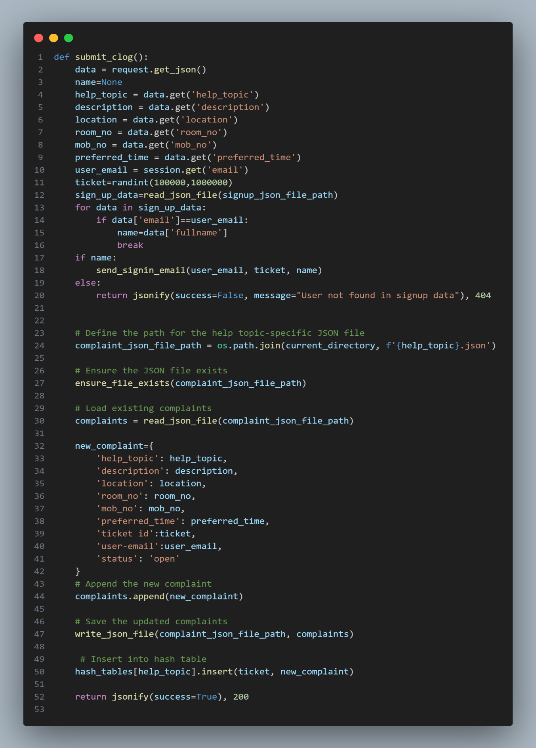

The ‘submit_clog’ method handles the submission of a new complaint log (clog).It serves as the main entry point for users to report complaints, ensuring the system captures all necessary information in a consistent manner

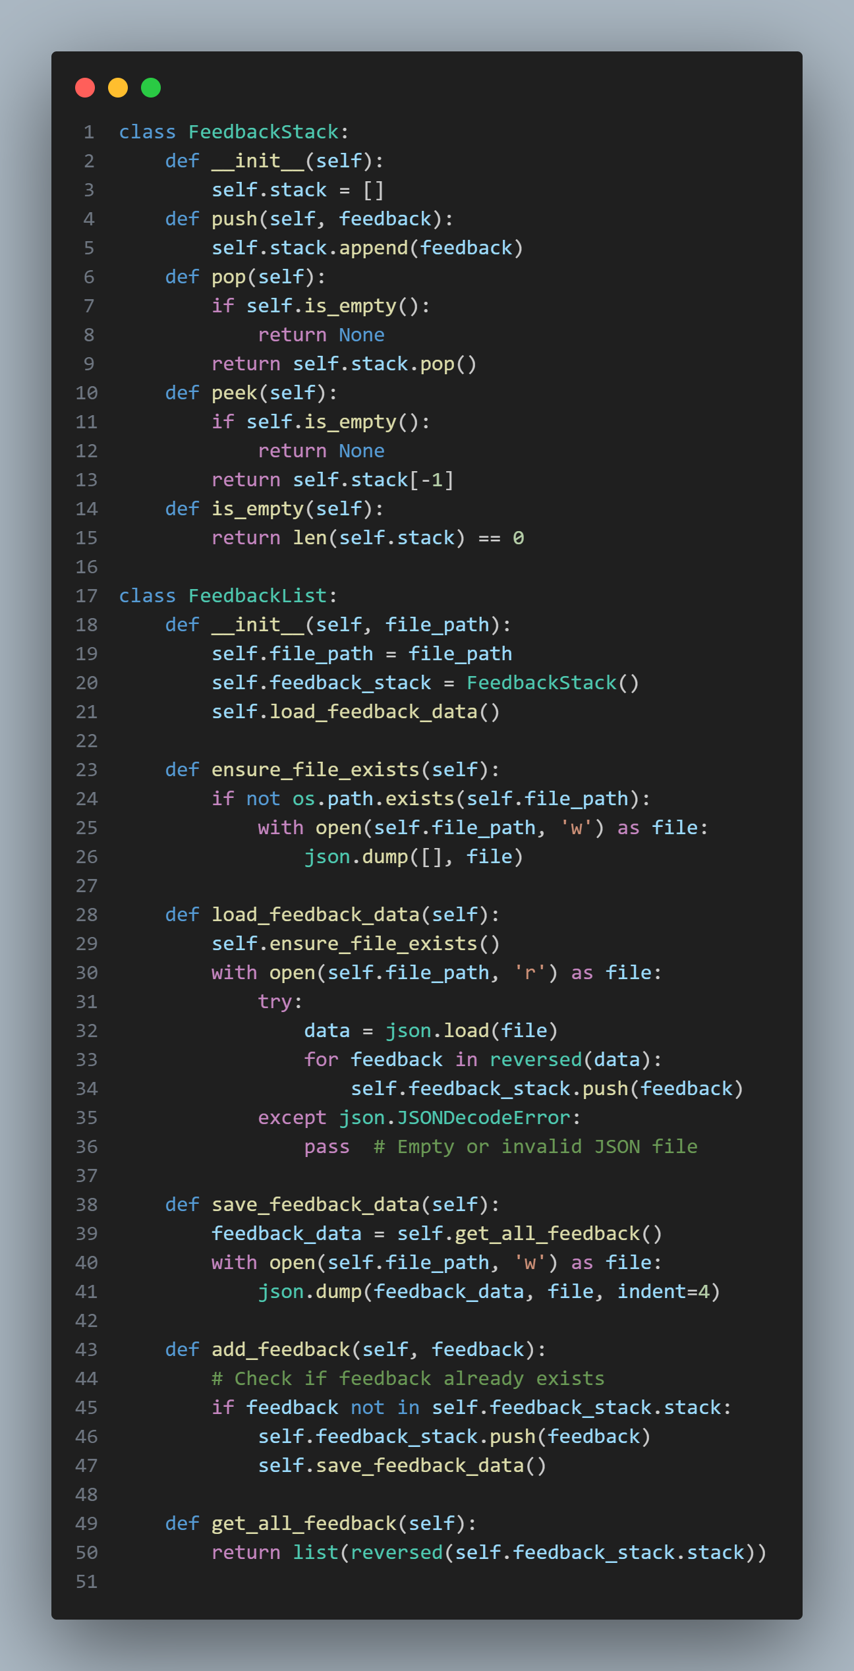

This snippet shows the creation and management of List ADT and stack for efficiently handling feedbacks.

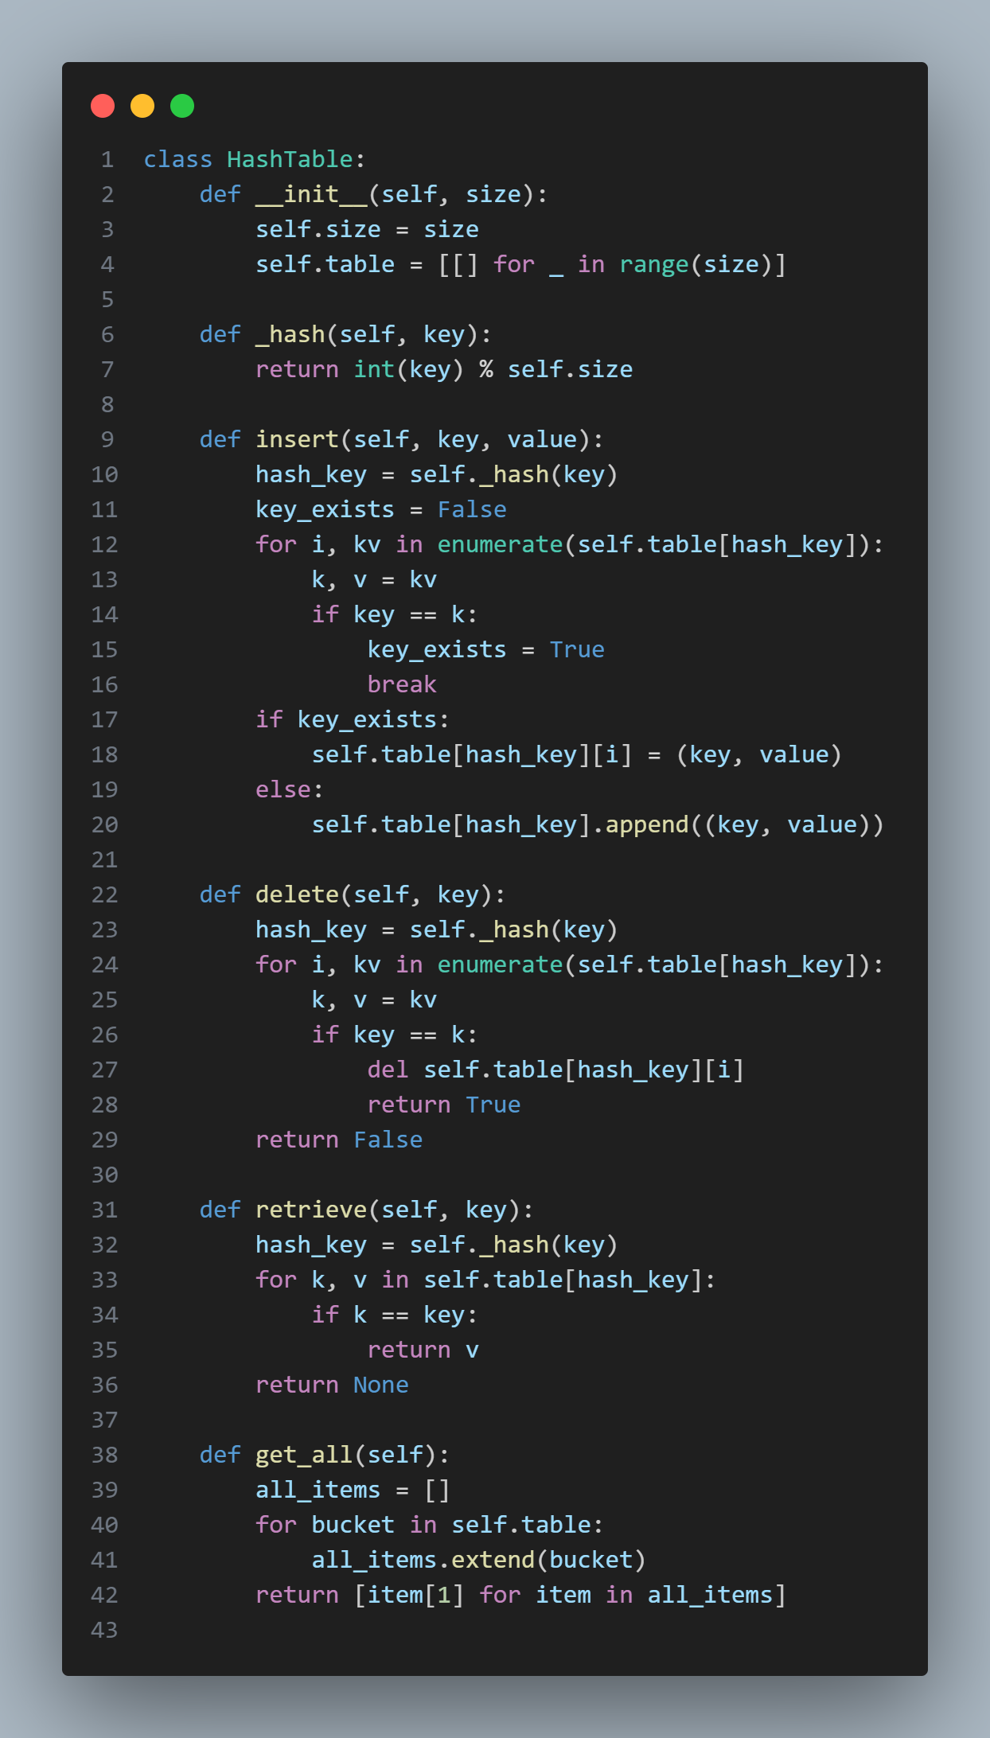

This snippet shows the creation and management of hash tables for tickets.

**SCREENSHOTS OF USER-INTERFACE**

**HOMEPAGE:**

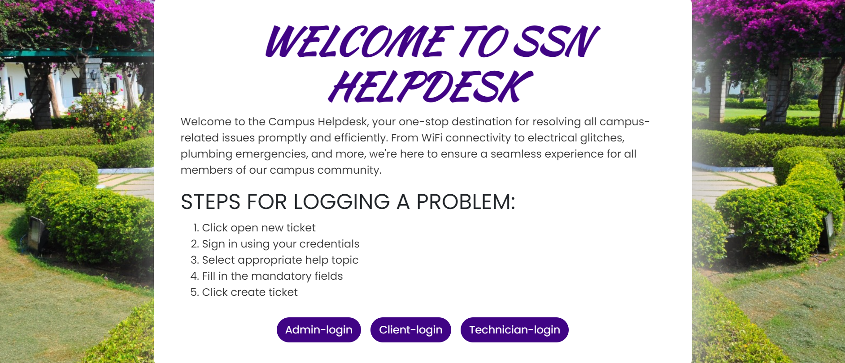

**ADMIN,CLIENT,TECHNICIAN LOGIN:**

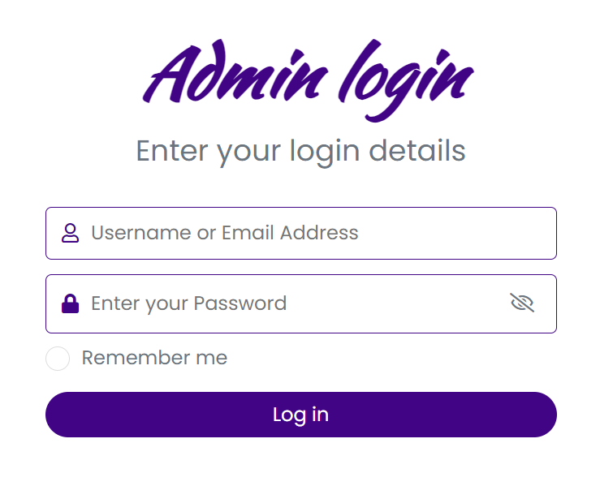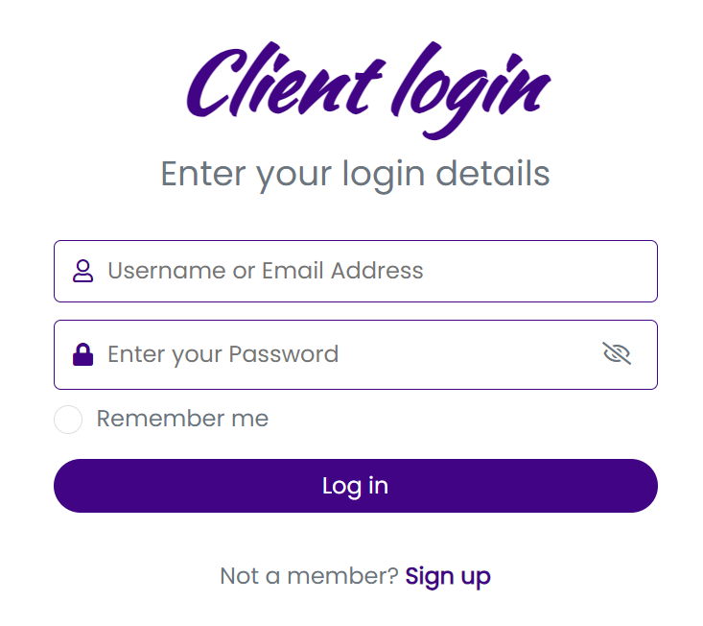

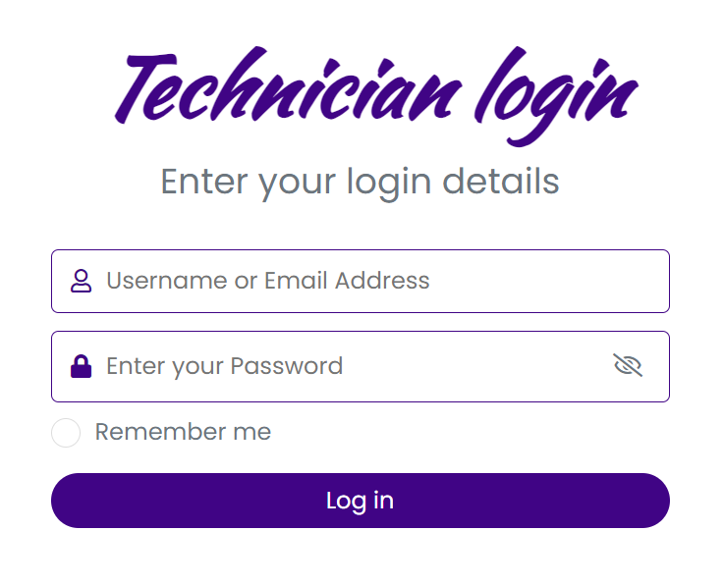

**TECHNICIAN’S DASHBOARD:**

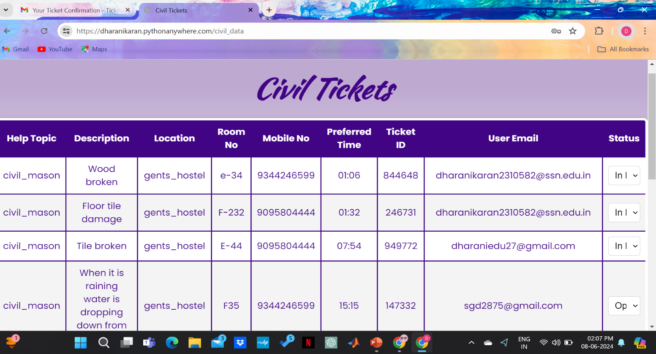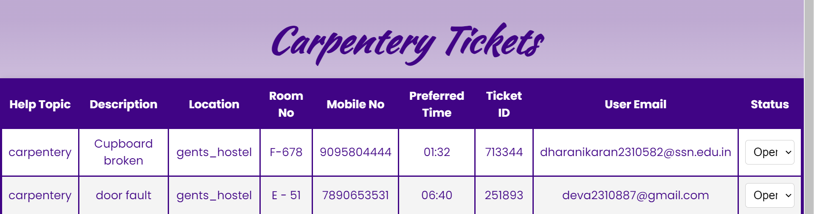

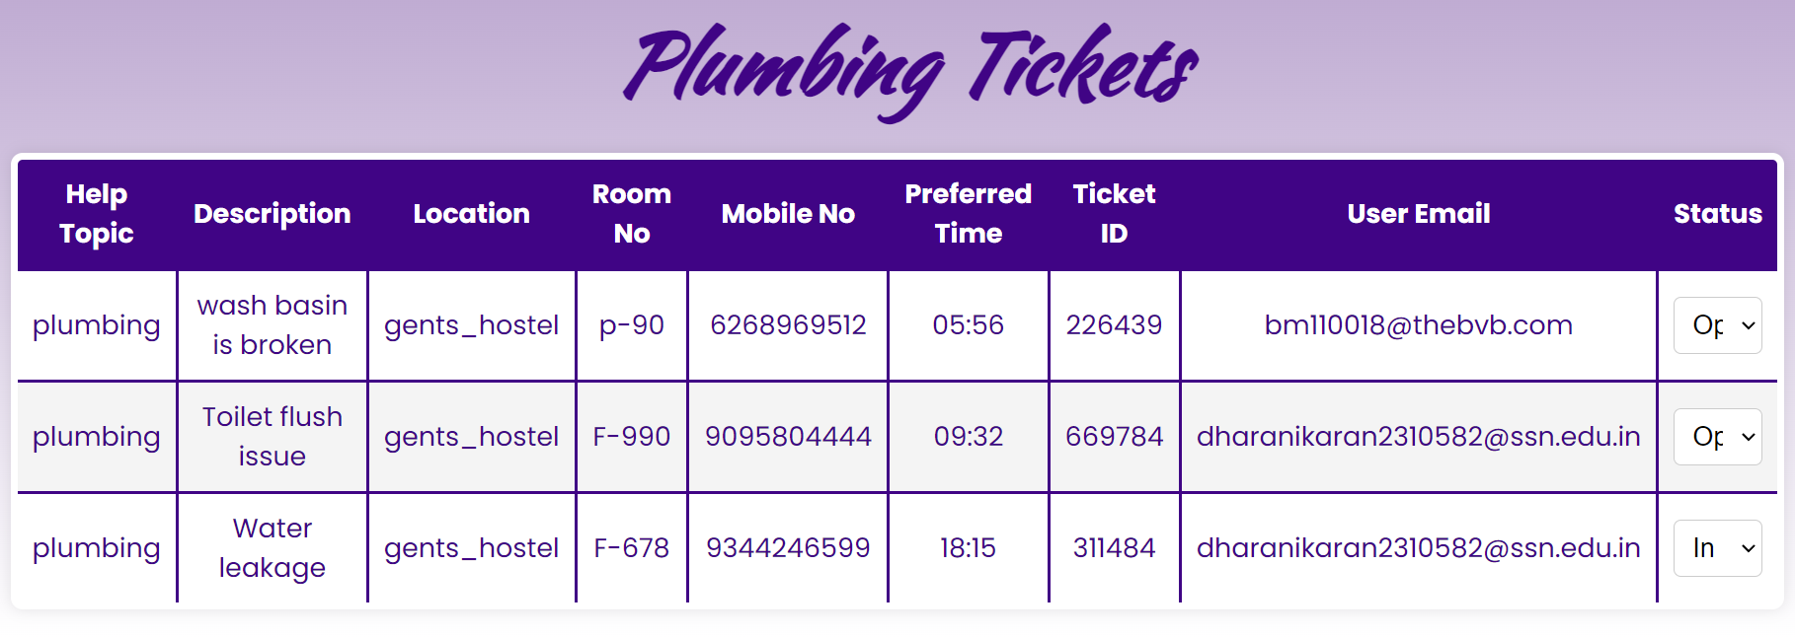

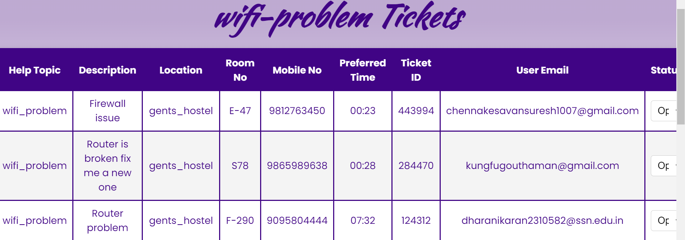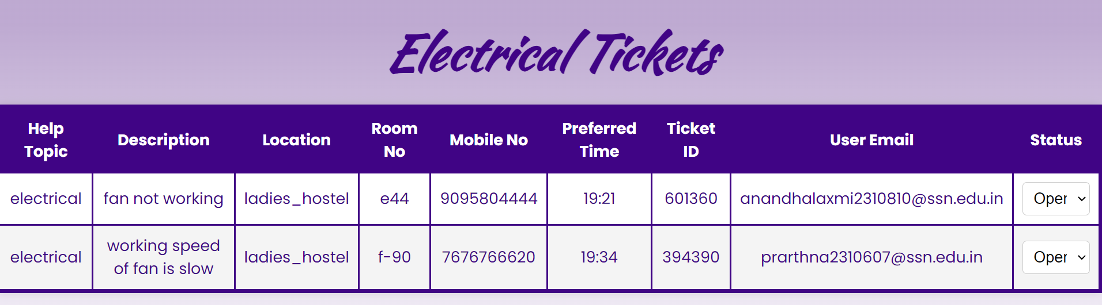

**COMPLAINT LOG PAGE:**

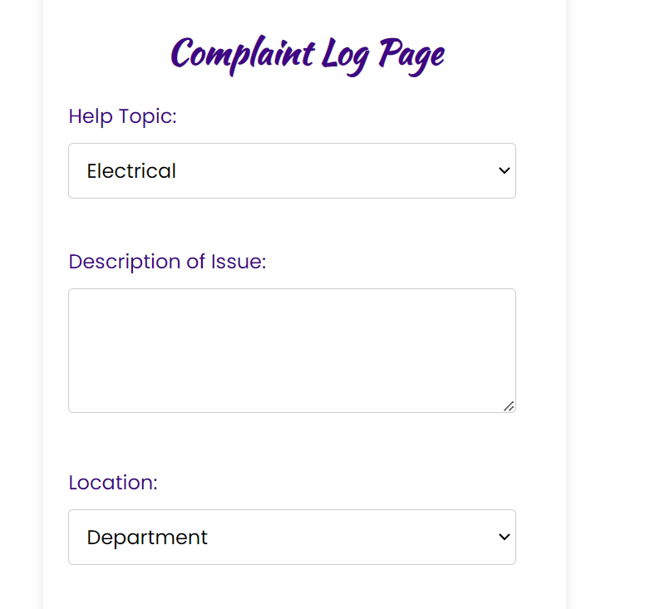

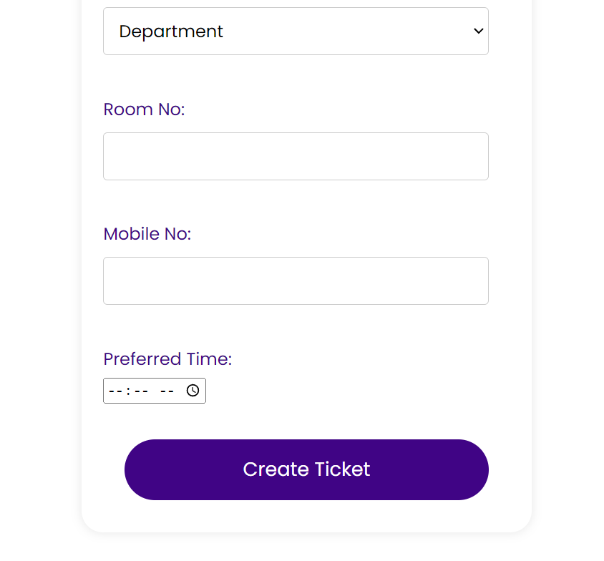

**ADMIN PAGE:**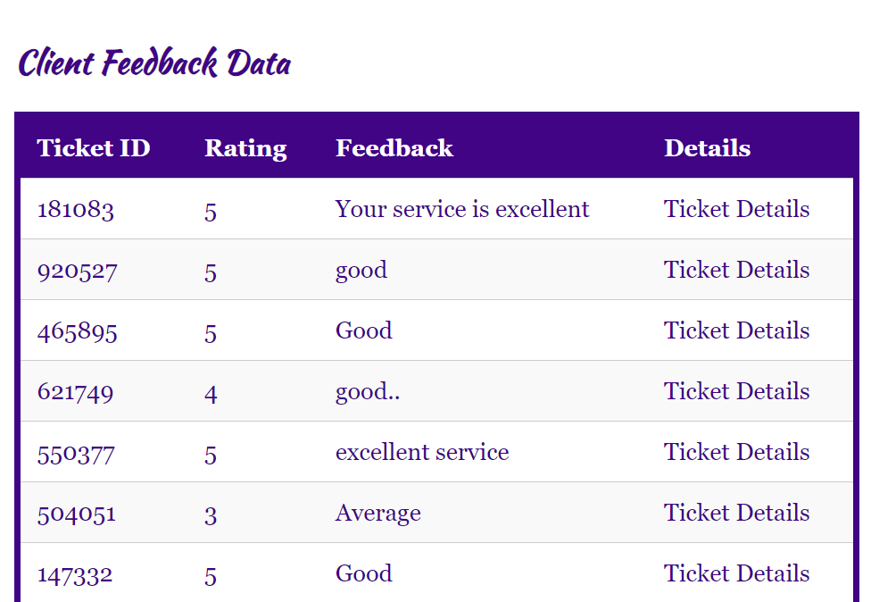

**TICKET STATUS(RESOLVED/OPEN/INPROGRESS):**

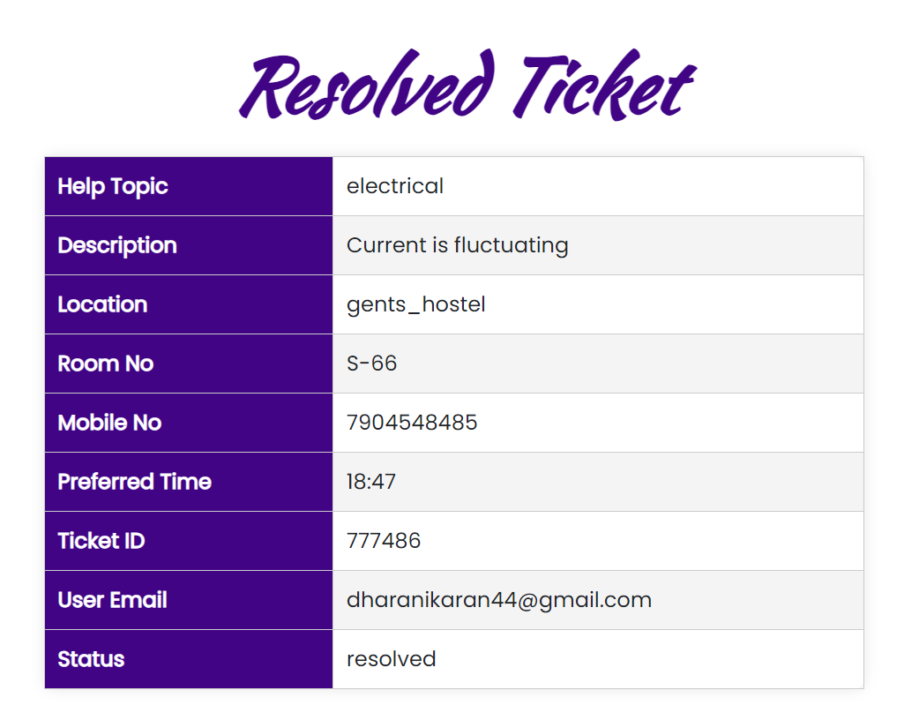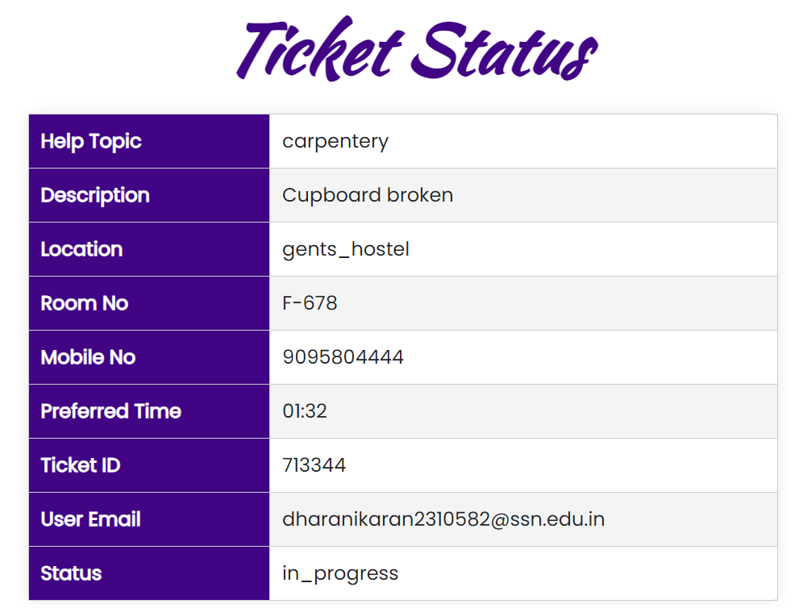

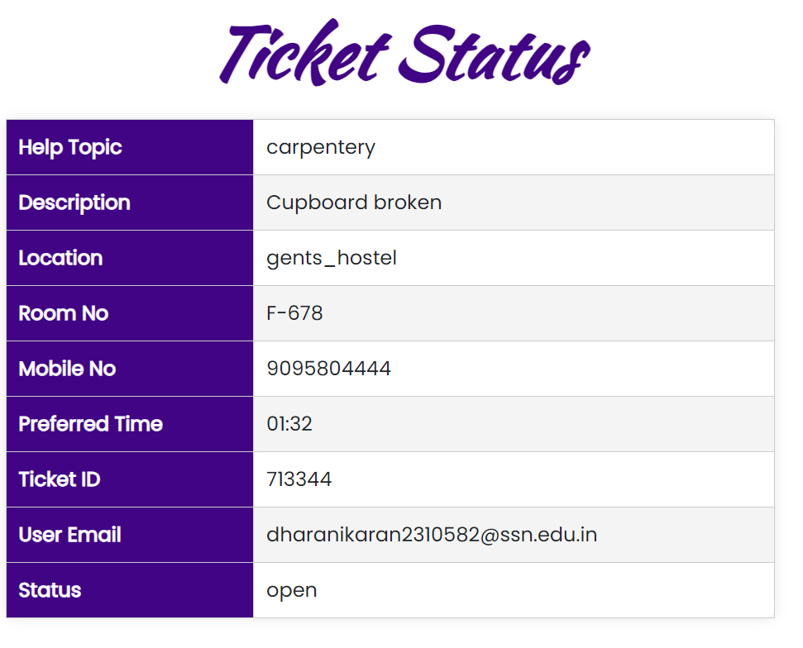

**FEEDBACK SUBMISSION FORM:**

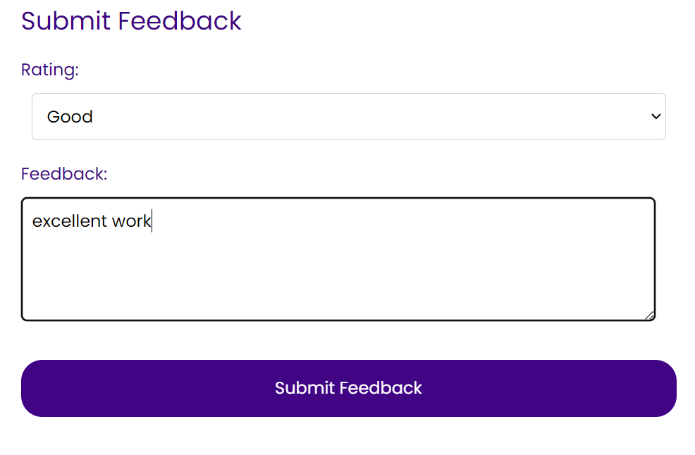

**CLIENT EVALUATION REPORT**

Project’s Name: Helpdesk Ticketing System

Name of the client: P.Jaish

**Rating System - 1: Strongly disagree 2: Disagree 3: Neutral 4: Agree 5: Strongly Agree**

|  |  |  |  |  |  |
| --- | --- | --- | --- | --- | --- |
| **Questions** | **1** | **2** | **3** | **4** | **5** |
| The problem was well discussed and the requirements and goals were clear. |  |  |  |  | ✔ |
| The project plan was well-defined and communicated from the start. |  |  |  |  | ✔ |
| The resources were adequate for achieving the goals. |  |  |  |  | ✔ |
| The original timeline was realistic and was followed. |  |  |  | ✔ |  |
| The teamwork was well demonstrated. |  |  |  | ✔ |  |
| The client was communicated on regular intervals and given updates on the progress of the project. |  |  |  | ✔ |  |
| The expected project requirements have been satisfied. |  |  |  |  | ✔ |

**CONCLUSION**

In conclusion, the Helpdesk Ticketing System project has effectively tackled the challenges associated with managing service requests within our organization. By developing and implementing this robust software solution, we have streamlined workflow processes, enhanced communication, and significantly improved the efficiency of issue resolution.

The project has delivered an intuitive user interface, allowing users to easily submit and track their service requests. The categorization of requests by type (e.g., carpentry, masonry, plumbing, internet, and electrical services) ensures that tasks are directed to the appropriate technicians, facilitating swift and accurate responses. Technicians, in turn, benefit from organized queues and detailed task descriptions, enabling them to prioritize and address issues effectively.

By integrating features such as real-time notifications and status updates, the system ensures that users are kept informed throughout the resolution process. The inclusion of reporting and analytics tools provides valuable insights into service performance, helping management to identify trends, allocate resources efficiently, and make data-driven decisions.

The use of secure, scalable Azure hosting guarantees reliable access to the system, promoting continuous availability and flexibility to accommodate future growth. Enhanced security measures, including authentication protocols and data encryption, ensure the protection of sensitive information.

Looking ahead, the Helpdesk Ticketing System can be further refined by incorporating additional features and functionalities based on user feedback and evolving organizational needs. Continuous monitoring, maintenance, and updates will ensure the system remains responsive and effective in addressing future requirements.

Overall, the Helpdesk Ticketing System project has significantly transformed the way our organization manages service requests. By leveraging advanced technology, we have successfully addressed the specific challenges of our helpdesk operations, resulting in improved efficiency, better communication, and a seamless experience for both users and technicians.

# REFERENCES

* https://[www.stackoverflow.com/](http://www.stackoverflow.com/)
* <https://youtube.com/playlist?list=PL-osiE80TeTs4UjLw5MM6OjgkjFeUxCYH&si=MzepalBTSZBv5K0D>
* <https://www.geeksforgeeks.org/learn-data-structures-and-algorithms-dsa-tutorial/>)